DBT Glue Project
Objective

- In this project, I am utilizing AWS Glue to extract data from an external API and store it in JSON format within an S3 bucket.
- After the data has been loaded into the S3 bucket, I use DBT (Data Build Tool) to transfer the data from the S3 bucket into a staging table in Snowflake, using DBT macros for automation.
- Additionally, I am taking advantage of DBT's modeling capabilities to create the necessary tables in Snowflake across different layers: raw, transform, and mart.
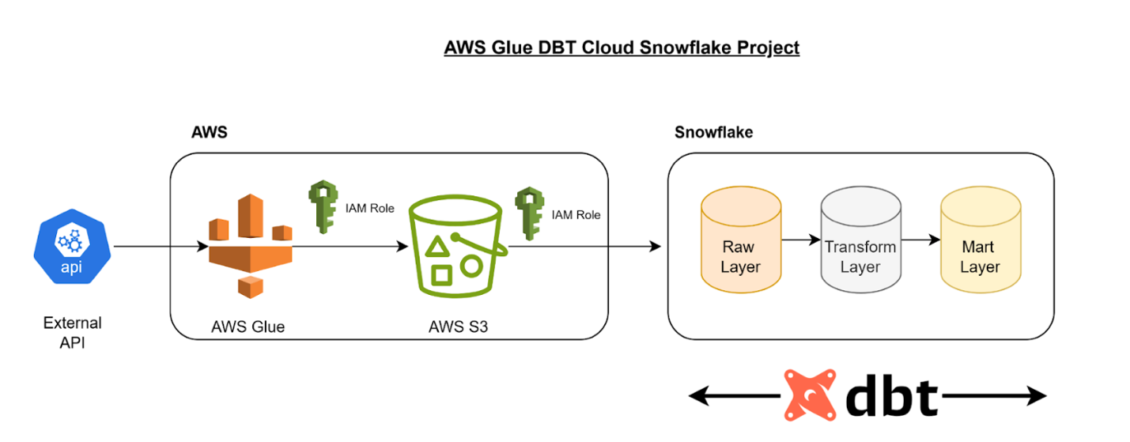

Overall Process
- Python script in AWS glue is run as a job to extract API data in json format.
- The glue job sends the data to S3 and then copied into external stage in Snowflake
- Using Snowflake as the data warehouse, DBT takes the raw data from raw layer and transforms data.
- Transformed data is then sent to Mart Layer(gold) for data analyst and business users.
DBT Process
- A macro is created to allow the data to be copied into snowflake initial table from external stage in snowflake
- In the raw folder, the raw data is saved as a new table with date and timestamp added along with an initial flatten
- This raw table is then referenced in the transform folder for transformations such as further flattening the json file.
- Finally, in the mart folder is where the final output of the data resides as it refrences the transformed data.
- A DBT job is setup to run the models on demand or on a schedule so changes can be processed.
DBT Lineage
